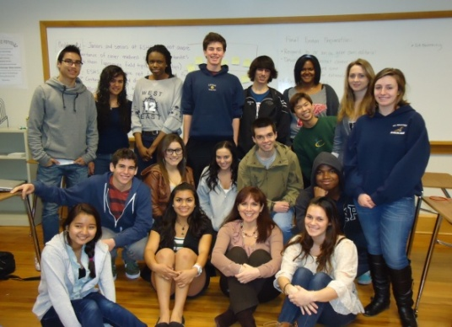

El Segundo high school

Career Pathways & Workforce Readiness

Presents

**“Your Career Path Starts Here”**

Friday, March 9, 2012

10:15-11:15 A.M.

El Segundo Performing Arts Center

640 Main Street

El Segundo, CA 90245

(Limited Parking in Faculty Parking Lot on Mariposa Ave)

Please join us as an honored guest.

* Come be inspired by students as they share a powerful message with their peers about the New Economy, education, and the global workforce.
* Learn about the new and vital **Career Readiness Resources** available at El Segundo High School.



**Please RSVP by March 6.**

Linal Miller [lmiller@esusd.k12.ca.us](mailto:lmiller@esusd.k12.ca.us)

310-615-2662 Ext.314